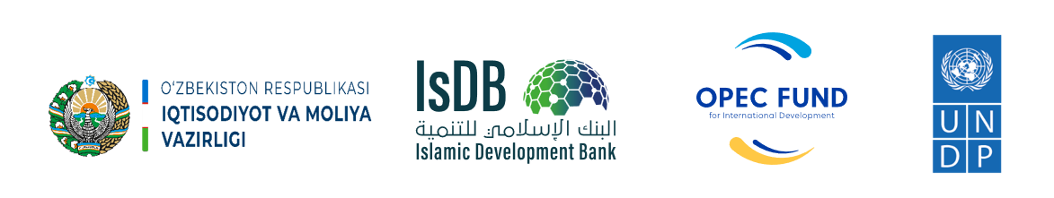
Islamic Development Bank
Ministry of Economy and Finance of the Republic of Uzbekistan
United Nations Development Programme in Uzbekistan

Project Title: | Joint project of the Ministry of Economy and Finance of the Republic of Uzbekistan and UNDP Component B "Engineering Services and Strengthening Capacity in Infrastructure Management" of the "Sustainable Rural Development" financed by Islamic Development Bank and OPEC Fund for International Development
Country: | Uzbekistan
Contract Number: | Agreement for delivery outputs
Implementation period: | 8 June 2022 – 31 December 2025 (43 months)
PROJECT NARRATIVE REPORT

Reporting period: | January 1 – December 31, 2024
Report prepared by: | UNDP CO Uzbekistan

Tashkent 2024

Table of Contents
ABBREVIATIONS & ACRONYMS 3
TITLE LIST 4
SECTION 1. OVERALL INFORMATION 5
PROJECT SYNOPSIS 5
EXECUTIVE SUMMARY 8
SECTION 2. DESCRIPTION AND SUMMARY OF ANNUAL PROGRESS AND RESULTS 12
PROJECT IMPLEMENTATION PROGRESS 12
PROGRESS OF ACTIVITY 1. 12
PROGRESS OF ACTIVITY 2 23
PROGRESS OF ACTIVITY 3: 26
PROGRESS OF ACTIVITY 4: 30
PROGRESS OF ACTIVITY 5: 33
Annexes: 34

ABBREVIATIONS & ACRONYMS

APA | Annual Plan of Activities
AWP | Annual Work Plan
BOA | Budget of Action
BPR | Business Process Re-engineering
CDP  CDR | Community Development Plan  Combined Delivery Report
CO | Country Office
ECA | Ecologic and Climate Action Cluster
GOU  IA  IG | Government Operations Unit  Implementing Agency  Initiative Group
IsDB  LDP  LoA | Islamic Development Bank  Local Development Plan  Letter of Agreement
M&E | Monitoring and Evaluation
NIM | National Implementation Modality
NPC | National Project Coordinator
MEF | Ministry of Economy and Finance
OPEC Fund  PIR  PIU | OPEC Fund for International Development  Project Implementation review  Project Implementation Unit
PM | Project Manager
POPP | Programme and Operations Policies and Procedures
QMS  RBM | Quality Management System  Results-Based Management
RIA | Regulatory Impact Assessment
SDG | Sustainable Development Goals
TOR  TOT  TWG | Terms of Reference  Training for Trainers  Technical Working Group
UNDP | United Nations Development Programme
USD | United States Dollar
WB | World Bank

TITLE LIST
Project number and title: | 00129160  IsDB Sustainable Rural Development Project Component B: Engineering Services and Strengthening Capacity in Infrastructure Management
Project Starting date: | 8 June 2022
Project completion date: | 31 December 2025
Implementing Partner: | Ministry of Economy and Finance of the Republic of Uzbekistan
Donor (s): | Islamic Development Bank & OPEC Fund for International Development
Contract # | Agreement to delivery output between

Total Budget for entire project period | Original Budget (USD) | Latest Signed Revision (USD)
Total Budget for entire project period | 5,000,000.00 | 5,000,000.00

Resources | Donor | Amount (USD)
Resources | Islamic Development Bank | 5,000,000.00
Resources | UNDP (in kind) | 3 050 000.00
Resources | Government  (Parallel or cost-sharing) | N/A

Period covered by this report: | 01.01.2024 – 31.12.2024
Date of annual review (Project Board meeting): | 10.12.2024

Budget for reporting period (as per the Annex III – the Budget for the Action) | Budget (USD)  (01.01.2024 – 31.12.2024) | Expenditure till  31 December 2024 (USD)
 | 1,462,743.22 | 1,250,781.56

SECTION 1. OVERALL INFORMATION

PROJECT SYNOPSIS
Project title | IsDB Sustainable Rural Development Project Component B: Engineering Services and Strengthening Capacity in Infrastructure Management
Project number | 00129160
Country | Republic of Uzbekistan
Overall objective | This UNDP Project is an integral component of the broader Uzbekistan - Sustainable Rural Development Project financed by the Islamic Development Bank (IsDB) and executed by the Ministry of Economy and Finance. The overall objective of UNDP Project is to empower and build capacities of local partners (communities, architects, engineers, local authorities) in developing and implementing local development plans and promoting locally relevant green and energy efficient as well as digital solutions. The Project aims to build capacities of targeted communities and partners in adopting and implementing environmentally friendly solutions. The Project will also confer positive impacts on human development through increased economic opportunities and wellbeing of targeted communities. Climate-related concerns will be mainstreamed into decision-making at all levels, facilitating climate-resilient and energy efficient development from the community level up to the regional level. The project takes a people-centered, gender sensitive and climate risk-informed holistic approach.
Outcome | Number of innovative and scalable solutions applied through systems integration in the Aral Sea region
Outputs | - Output 1. Capacities of targeted local communities increased to identify local needs and to develop plans of actions, i.e., Community Development Plans (CDP), by identifying priority infrastructures for investments that have optimum and long-term benefits through an inclusive community engagement (including women and youth) and consultation with sub-regional and local authorities.  - Output 2. Capacities of local architecture-design institutions and regional departments of architecture and construction are enhanced for development of improved engineering designs and master plans that are responsive to the sustainability aspects (economic, operational, and environment sustainability), innovative energy and water efficient, low carbon technology, climate resilient and gender responsive, and promoting local resources.  - Output 3. Capacities of construction, architecture-design and public service delivery sector are increased on the local governance and community participatory mechanism in the planning and implementation of rural development programs and initiatives by using digital transformation, gender-sensitive approaches, innovative IT solutions, including development of digital infrastructure and information systems to ensure better access to social facilities and services in rural areas, including green redevelopment/regeneration and increasing resilience in post-disaster situations (such as COVID-19 and other pandemics).  - Output 4. Local communities are strengthened empowering women, youth, elderly, people with disabilities, involving in decision making processes and national/sub-regional/local government capacities and institutionalization in operation and maintenance of the infrastructure to ensure sustainable functioning.  - Output 5. Project Management
Activities | Output 1: (1.1) Identification/verification of target communities (170 communities) in 20 districts of Karakalpakstan, Khorezm, Bukhara and Navoi regions; (1.2) Capacity building in target districts on community mobilization for identification of community needs (up to 40 people at each community, total 6800 people); (1.3) Development and implementation of the gender-responsive CDPs at the qishloq/community level (up to 170) relying on extensive and inclusive communities mobilization in targeted communities; (1.4) Facilitate the institutionalization of the CDPs at the district administration level (inclusion of the CDP priorities and monitoring systems for CDPs into the district development plans of the government), including through engaging the locally selected deputies; (1.5) Identification/verification of target communities (around 200 communities) for the 2nd stage of the IsDB Program, from the Samarkand, Kashkadarya and Surkhandarya regions; (1.6) Organization of workshops with community participation (around 1500) and development of around 200 cluster based CDPs  Output 2: (2.1) Research on adverse impact of the ecological disaster and environment degradation on agriculture and rural population and identification of locally relevant sustainable environmentally friendly solutions.; (2.2) Building capacity of local architects/engineers by promoting innovative solutions aimed at energy and water saving, reducing CO2 emission for climate resilient planning, with focus on local agriculture and social infrastructure with particular focus on different needs of concerned groups, including women, youth, people living in poverty and people with disabilities; (2.3) Introduction of energy and water efficient, new agriculture & farming technologies, ozone-friendly and low GWP (global-warming potential) based technologies in different sectors/applications in a balanced proportion of pilot projects.  Output 3: (3.1) Digital readiness assessment, including digital gender gap, and development of local digitalization plans; (3.2) Capacity building to support regional digital transformation (25 people at each supported region, total 100 people); (3.3) Increasing digital literacy for rural population in target villages/qishloqs, with focus on students, youth communities, cooperatives, water-users associations, etc; (3.4) Based on the prioritization assessment under activity 3.1., improve access to social infrastructure through using modern technology/equipment and promoting/piloting the smart/green communities model.  Output 4: (4.1) Deployment of methods for effective and sustainable development of infrastructure in rural areas through promoting the local resource-based approaches; (4.2) Replication of Project best practices; (4.3) Development of a communication strategy in line with UNDP Principles of Gender-Sensitive Communications to make use of all possible advocacy and outreach tools and approaches to deliver messages to target audience, beneficiaries and wider public at community, district, sub-national, national and international levels; (4.4) Systems innovations advanced for integrated solutions in the Aral Sea region.
Target groups | - Population in targeted rural areas, particularly women, youth, elderly, people with disabilities  - Civil servants of government organizations and private sector who work in rural areas (doctors, architectures, farmers, teachers, designers, and others)
Project starting date | 8 June 2022
Project duration | 8 June 2022 – 31 December 2025 (43 months)

EXECUTIVE SUMMARY
Uzbekistan joined the Islamic Development Bank (IsDB) in 2003 year. Uzbekistan is a landlocked country strategically located in the heart of Central Asia, bordering Kazakhstan, Tajikistan, Kyrgyz Republic, Turkmenistan, and Afghanistan. It is a lower middle-income country and rich with mineral resources. With 35 million populations (2022), Uzbekistan accounts for about 45% of the Central Asian region's total population, whereas about half of population of Uzbekistan live in rural area. It has a territory of 448.9 thousand km².
The IsDB Sustainable Rural Development project – “IsDB Sustainable Rural Development Project Component B: Engineering Services and Strengthening Capacity in Infrastructure Management” (IsDB project) - is a timely support to the Government’s reform agenda to introduce successful innovative and scalable solutions applied through systems integration in the Aral Sea region.
The project has four major objectives. First one is to empower and to build capacities of local partners (communities, architects, engineers, local authorities) in developing and implementing community & local development plans and promoting locally relevant green and energy efficient as well as digital solutions. The second objective is to build capacities of targeted communities and partners in adopting and implementing environmentally friendly solutions. The third objective is to confer positive impacts on human development through increased economic opportunities and wellbeing of targeted communities as well as to mainstream climate-related concerns into decision-making at all levels, to facilitate climate-resilient and energy efficient development from the community level up to the regional level. And the fourth final objective is to take a people-centered, gender sensitive and climate risk-informed holistic approach.
To achieve main outcome and major objectives, the project has been implemented by four pillars/components and one supportive component/pillar:
Component 1. Capacities of targeted local communities increased to identify local needs and to develop plans of actions, i.e., Community Development Plans (CDP), by identifying priority infrastructures for investments that have optimum and long-term benefits through an inclusive community engagement (including women and youth) and consultation with sub-regional and local authorities.
Component 2: Capacities of local architecture-design institutions and regional departments of architecture and construction are enhanced for development of improved engineering designs and master plans that are responsive to the sustainability aspects (economic, operational, and environment sustainability), innovative energy and water efficient, low carbon technology, climate resilient and gender responsive, and promoting local resources.
Component 3: Capacities of construction, architecture-design and public service delivery sector are increased on the local governance and community participatory mechanism in the planning and implementation of rural development programs and initiatives by using digital transformation, gender-sensitive approaches, innovative IT solutions, including development of digital infrastructure and information systems to ensure better access to social facilities and services in rural areas, including green redevelopment/regeneration and increasing resilience in post-disaster situations (such as COVID-19 and other pandemics).
Component 4: Local communities are strengthened empowering women, youth, elderly, people with disabilities, involving in decision making processes and national/sub-regional/local government capacities and institutionalization in operation and maintenance of the infrastructure to ensure sustainable functioning.
Component 5: Project management
The project will find solutions for the key barriers to sustainable environmentally friendly and energy efficient development and digital solutions in rural areas supporting human development in the areas affected by the Aral Sea disaster. Here are as major challenges and barriers work for:
- Insufficient knowledge base, information, and communication on the environmentally friendly, gender-sensitive, energy efficient and digital rural areas-tailored solutions in the areas of architecture, social infrastructure, and community development.
- Limited capacities and incentives for local authorities to identify, develop and implement the environmentally friendly, gender-sensitive, energy efficient and digital rural solutions in the areas of architecture, social infrastructure, and community development.
- Limited opportunities and capacities of communities to develop plans of local development.
- Lack of gender and age disaggregated data.
The project implementation started officially on June 8 with the annual approved budget of USD 587,520 for the 2022 year and continued with an annual approved budget of USD 1,834,752.43 for the 2023 year, and 1,462,743.22 was allocated for the year 2024. IsDB and OPEC Fund are the main donors of the project. The project is operational in 4 pilot regions of Uzbekistan: Karakalpakstan Republic, Khorezm, Bukhara and Navoi regions.
In the reporting period, UNDP continued to work jointly with the PIU under the Ministry of Economy and Finance in the selected 170 communities located in 20 districts of Karakalpakstan, Khorezm, Bukhara and Navoi regions by implementing activities of all four components.
In 2024, the project continued to work on the development of Cluster Community Development Plans for 170 communities. Specifically, it developed new gender-responsive cluster CDPs for 40 communities and reviewed CDPs for 170 communities. These communities were distributed as follows: 41 in Bukhara, 46 in Karakalpakstan, 49 in Khorezm, and 34 in Navoi. The improvement of the methodology was based on local circumstances, lessons learned, World Bank and other donors' experience in Uzbekistan, and international best practices. During the reporting period, the Initiative Groups (IG) were revised and updated totaling 1791 people. Some IG members discontinued volunteering for several reasons such as movement to another location, their work schedules illness, or losing interest in the project.
Training modules were created to build the capacity of the IGs members, focusing on community needs assessment, project development, and monitoring and evaluation. A summer school was organized for IG members to enhance their roles and tasks. The project also conducted an annual review of 40 Cluster Gender Responsive Community Development Plans (CDPs) and provided training for district representatives on integrating CDPs into the yearly planning.
The project focused on addressing environmental and agricultural challenges by researching the negative effects of ecological disasters and promoting sustainable solutions. It provided capacity-building opportunities for local architects and engineers, emphasizing innovative and sustainable practices. Additionally, the project introduced drip irrigation and low-carbon technologies and offered training for farmers on crop diversity and the utilization of agro-meteorogical stations.
The digital transformation efforts involved evaluating and creating plans for digitalization, as well as providing training to youth on online trading skills and artificial intelligence technologies. The project included the procurement and installation of IT equipment in rural schools and medical facilities, and the establishment of community resource centers to offer e-government services.

The project organized study tours and training sessions to empower local communities on best practices in project management, rural development, and community mobilization. The project also documented its impacts through filming, publication of visibility materials, and training for PR specialists.
Specifically, capacity building and CDP activities included the following:
- Development of the Concept of Initiative Group;
- Summer school for IG members with the participation of representatives from the PIU, UNDP project team, UNDP staff, and an IsDB representative;
- TOT for on-site project team in Project Design in four regions;
- Training in Project Design for IG members;
- Training in Monitoring and Evaluation for IG members;
- Training on CDP integration into action plans for district authorities;
- Training on crop diversity for farmers and agriculture sector specialists;
- Training on effective use of agro-meteorological stations for farmers;
- Organized international certified training on developing and implementing strategies for sustainable rural infrastructure development in Turkey;
- Organized study tour to Spain, Latvia, and Slovakia, on rural development, sustainability, capacity building CDPs, smart agriculture, and sustainable infrastructure;
- 40 Gender-responsive CDPs revised;
- Design and deployment of CDP monitoring website.
Besides the CDP process, the project initiated and conducted several field assessments in 2024. Specifically, some key assessments are as follows:
- Analysis and development of poverty maps in 15 socio-economic topics;
- Functional review of 4 selected pilot communities (Talaliyon in Bukhara, Khidoyat in Khorezm, Zarmetan in Navoi, and Samanbay in Karakalpakstan;
- Local Development Plan of Vabkent district (Bukhara);
- Contests "Adverse Impact of Ecological Disaster in Aral Sea Region" and "Smart agriculture" among journalists, photographers, bloggers and students.

In terms of project management, annual work plans and budgets were developed and approved. Project staff and specialists were recruited according to UNDP procedures. The project held its 4th and 5th Project Board Meetings and submitted necessary reports to the Ministry of Economy and Finance.
The project implemented a gender-sensitive communication strategy, which significantly improved its visibility. In 2024, the project produced and shared over 500 publications across various social media platforms, including Facebook, LinkedIn, Twitter, Instagram, and Telegram, as well as national and international mass media outlets. Additionally, it issued 44 press releases and created videos, animated content, infographics, posters, and other visibility materials.
Overall, the project made significant strides in community mobilization, capacity building, environmental sustainability, digital transformation, and project management, with a strong emphasis on gender responsiveness, local governance, and sustainable development practices.
The project team continued to collaborate with other UNDP initiatives to share best practices and ensure cooperation and synergy in their activities. One example is the "Project for Supporting Self-Reliance through Climate-Resilient Agriculture in the Aral Sea Region," which successfully adapted and replicated the Community Development Plans (CDPs) methodology to align with its objectives. Additionally, project activities included the installation of information kiosks, agro-meteo stations, and propane air conditioners. Schools in rural areas received ICT equipment for their IT classrooms.
The fourth and fifth Project Board Meetings were held in March and December, respectively, with representatives from national ministries, agencies, institutions, and regional authorities of Karakalpakstan, Khorezm, Bukhara, and Navoi regions invited, along with participants from IsDB, UNDP, international financial institutions (IFIs), and other development partners. During these meetings, the project’s progress for 2024 and plans for 2025 were presented and discussed.

SECTION 2. DESCRIPTION AND SUMMARY OF ANNUAL PROGRESS AND RESULTS

PROJECT IMPLEMENTATION PROGRESS

PROGRESS OF ACTIVITY 1.
Capacities of targeted local communities increased to identify local needs and to develop plans of actions, i.e., Community Development Plans (CDP), are prepared by identifying the priority infrastructures for investments that have optimum and long-term benefits through an inclusive community engagement (including women and youth) and consultation with sub-regional and local authorities.
Activity 1.1 Identification/verification of target communities (170 communities) in 20 districts of Karakalpakstan, Khorezm, Bukhara and Navoi regions
Progress:
- 170 communities finalized and confirmed by the Project Implementation Unit:
- Bukhara region - 41 communities
- Karakalpakstan - 46 communities
- Khorezm region - 49 communities
- Navoi region - 34 communities

Output: N/A
Table 1. LIST OF 170 PILOT COMMUNITIES
 | District | Community | Main or adjacent community
 | THE REPUBLIC OF KARAKALPAKSTAN
1 | Amudarya | Toshyop | Main
2 | Amudarya | Farovon | Adjacent
3 | Amudarya | Olmazor | Adjacent
4 | Amudarya | Bosuv | Adjacent
5 | Amudarya | Urta qala | Main
6 | Amudarya | Arna buyi | Adjacent
7 | Amudarya | Dustlik | Adjacent
8 | Amudarya | Yangiobod | Adjacent
9 | Beruniy | Shimom | Main
10 | Beruniy | Lolazor | Adjacent
11 | Beruniy | Obihayot | Adjacent
12 | Beruniy | Abay | Main
13 | Beruniy | Dustlik | Adjacent
14 | Beruniy | Mahtumquli | Adjacent

15 | Nukus | Samanbay | Main
16 | Nukus | Massiv Kattagar | Adjacent
17 | Nukus | Akmangit | Adjacent
18 | Nukus | Toktau | Adjacent
19 | Nukus | Takirkol | Main
20 | Nukus | Darbent | Adjacent
21 | Nukus | Shorkol | Adjacent
22 | Nukus | Ornek | Adjacent
23 | Tahiyatash | Naymankol | Main
24 | Tahiyatash | Toshovul | Adjacent
25 | Tahiyatash | Nurli keleshek | Adjacent
26 | Tahiyatash | Doslik | Adjacent
27 | Tahiyatash | Keneges | Main
28 | Tahiyatash | Aytkushli | Adjacent
29 | Tahiyatash | Saraykol | Adjacent
30 | Tahiyatash | Kusshiliq | Adjacent
31 | Tahiyatash | Aydin jol | Adjacent
32 | Turtkul | Otayurt | Main
33 | Turtkul | Kaltaminor | Adjacent
34 | Turtkul | Pahtachi | Adjacent
35 | Turtkul | Ullubog | Adjacent
36 | Turtkul | Kuna Turtkul | Main
37 | Turtkul | Anhorli | Adjacent
38 | Turtkul | G'alaba | Adjacent
39 | Turtkul | Dustlik | Adjacent
40 | Ellikqala | Sarabiy | Main
41 | Ellikqala | Qoshqura | Adjacent
42 | Ellikqala | Ihlos | Adjacent
43 | Ellikqala | Amirobod | Adjacent
44 | Ellikqala | Qilchinoq | Main
45 | Ellikqala | Pahtachi | Adjacent
46 | Ellikqala | Chupon | Adjacent
 | KHOREZM REGION
47 | Yangibozor | Buston | Main
48 | Yangibozor | Tozadurman | Adjacent
49 | Yangibozor | Shirinlar | Adjacent
50 | Yangibozor | Pahlavon Mahmud | Adjacent
51 | Yangibozor | Yangi yop | Adjacent
52 | Yangibozor | Hamid Olimjon | Main
53 | Yangibozor | Barhayot | Adjacent
54 | Yangibozor | Shoirlar | Adjacent
55 | Yangibozor | Yuqori boshqir | Adjacent
56 | Xonqa | Dustlik | Main
57 | Xonqa | Ilgor | Adjacent
58 | Xonqa | Istiqlol | Adjacent
59 | Xonqa | Pahlavonlar | Adjacent
60 | Xonqa | Qoramozi | Main
61 | Xonqa | Guliston | Adjacent
62 | Xonqa | Paxtagul | Adjacent
63 | Xonqa | Dormon | Adjacent
64 | Bagat | Uzumzor | Main
65 | Bagat | Bogiston | Adjacent
66 | Bagat | O`zgarish | Adjacent
67 | Bagat | Hunarmand | Adjacent
68 | Bagat | Yangiqadam | Main
69 | Bagat | Galaba | Adjacent
70 | Bagat | Madaniyat | Adjacent
71 | Bagat | Navruz | Adjacent
72 | Xazorasp | Muxomon | Main
73 | Xazorasp | Kamolot | Adjacent
74 | Xazorasp | Navruz | Adjacent
75 | Xazorasp | Buyuk Siymo | Adjacent
76 | Xazorasp | Shoduhurram | Adjacent
77 | Xazorasp | Buston | Main
78 | Xazorasp | Qovunchi | Adjacent
79 | Xazorasp | Bogiroglar | Adjacent
80 | Gurlan | Dehqon | Main
81 | Gurlan | Ziyokor | Adjacent
82 | Gurlan | Navbir yop | Adjacent
83 | Gurlan | Qangli | Adjacent
84 | Gurlan | Dusimbiy | Main
85 | Gurlan | Marbugat | Adjacent
86 | Gurlan | Olchin | Adjacent
87 | Gurlan | Oqqum | Adjacent
88 | Urgench | Yuqoriovul | Main
89 | Urgench | Jayhun | Adjacent
90 | Urgench | Merganovul | Adjacent
91 | Urgench | Uyshin | Adjacent
92 | Urgench | Hidoyat | Main
93 | Urgench | Baxshilar | Adjacent
94 | Urgench | Gulobod | Adjacent
95 | Urgench | Hilol | Adjacent
 | BUKHARA REGION
96 | Bukhara | Talaliyon | Main
97 | Bukhara | Amirobod Gulistonobod | Adjacent
98 | Bukhara | Kunjiqala | Adjacent
99 | Bukhara | Novmetan | Adjacent
100 | Bukhara | Yangi Turmush | Main
101 | Bukhara | Istiqbol | Adjacent
102 | Bukhara | Rabotak | Adjacent
103 | Bukhara | Saxovat | Adjacent
104 | Vabkent | Mirvoshi | Main
105 | Vabkent | Hajuvon | Adjacent
106 | Vabkent | Nayman | Adjacent
107 | Vabkent | Sufidehqon | Adjacent
108 | Vabkent | Shanba | Main
109 | Vabkent | Xujarabot | Adjacent
110 | Vabkent | Kulxatib | Adjacent
111 | Vabkent | Garibshox | Adjacent
112 | Gijduvan | Gulistonobod | Main
113 | Gijduvan | Havzak | Adjacent
114 | Gijduvan | Zargaron | Adjacent
115 | Gijduvan | Takhtakhon | Adjacent
116 | Gijduvan | Jovgari | Main
117 | Gijduvan | Labirut | Adjacent
118 | Gijduvan | Gajdumak | Adjacent
119 | Gijduvan | Oqgul | Adjacent
120 | Gijduvan | Chagdari | Adjacent
121 | Kagan | Mustaqillik | Main
122 | Kagan | Yangi Hayot | Adjacent
123 | Kagan | Navroz | Adjacent
124 | Kagan | Beklar | Adjacent
125 | Kagan | Sarayon | Main
126 | Kagan | Choloki | Adjacent
127 | Kagan | B. Naqshband | Adjacent
128 | Kagan | Kogon | Adjacent
129 | Shafirkan | Mirzoqul | Main
130 | Shafirkan | Xorkash | Adjacent
131 | Shafirkan | Dormon | Adjacent
132 | Shafirkan | Bobur | Adjacent
133 | Shafirkan | Tezguzar | Main
134 | Shafirkan | Bobohaydar | Adjacent
135 | Shafirkan | Paxtaobod | Adjacent
136 | Shafirkan | Pashmon | Adjacent
 | NAVOI REGION
137 | Karmana | Varq | Main
138 | Karmana | Kalovot | Adjacent
139 | Karmana | Dehqon | Adjacent
140 | Karmana | Gulobod | Adjacent
141 | Karmana | Katta machit | Adjacent
142 | Karmana | Talqoq | Adjacent
143 | Karmana | Azamat | Main
144 | Karmana | Kumushkon | Adjacent
145 | Karmana | Kahramon | Adjacent
146 | Karmana | Dostlik | Adjacent
147 | Karmana | Yangiobod | Adjacent
148 | Karmana | Uyrot | Adjacent
149 | Karmana | Ayronchi | Adjacent
150 | Kiziltepa | Zarmetan | Main
151 | Kiziltepa | Azizobod | Adjacent
152 | Kiziltepa | Varozun | Adjacent
153 | Kiziltepa | Arabhona | Adjacent
154 | Kiziltepa | Rabot | Adjacent
155 | Kiziltepa | Oqmachit | Main
156 | Kiziltepa | Hafkoriyon | Adjacent
157 | Kiziltepa | Pahtaobod | Adjacent
158 | Kiziltepa | Tojikon | Adjacent
159 | Navbahor | Navkar | Main
160 | Navbahor | Sarbozor | Adjacent
161 | Navbahor | Chorvoqguzar | Adjacent
162 | Navbahor | Arabhona | Adjacent
163 | Navbahor | Kuhron | Adjacent
164 | Navbahor | Kelachi | Adjacent
165 | Navbahor | Pahtakor | Main
166 | Navbahor | Yangiyol | Adjacent
167 | Navbahor | Gujbogtepa | Adjacent
168 | Navbahor | Korovultepa | Adjacent
169 | Navbahor | Navbahor | Adjacent
170 | Navbahor | Burkut | Adjacent
Target regions and communities:
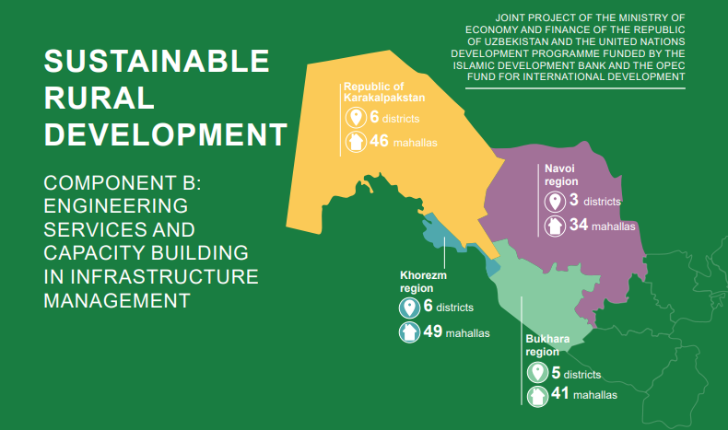
Activity 1.2 Capacity building in target districts on community mobilization for identification of community needs (up to 40 people at each community, total 6800 people)
Progress:
- Development of PR product
- The visibility materials (posters) to strengthen the capacity of the pilot communities on the degradation of the ecosystem in the Uzbek language developed:
- Water use efficiency
- Energy efficiency
- Environment
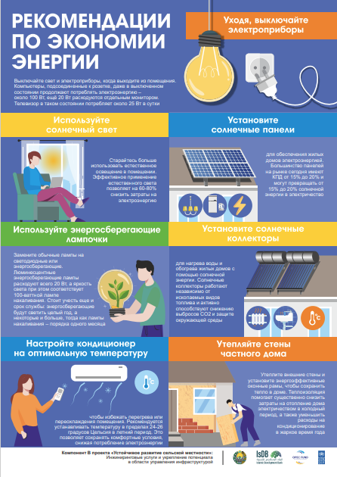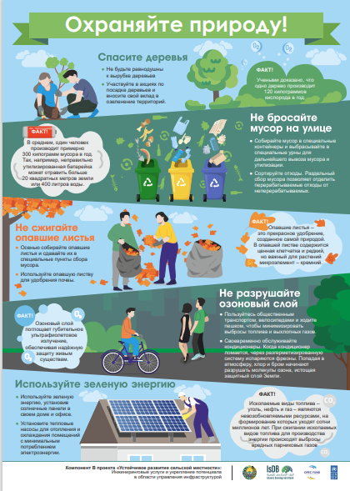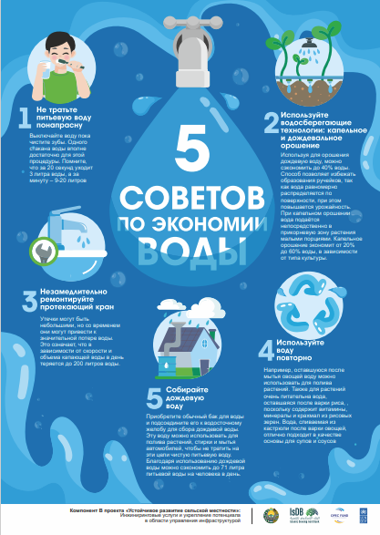

3. Summer school was conducted with the participation of the selected active 20 Initiative Group members, including 10 females (50%) and 10 males, as well as representatives from the PIU, UNDP project team, UNDP staff, and an IsDB representative.
4. Initiative Groups, including representatives from different sectors such as education, health care, business, and mahalla committees, were updated in four pilot regions. As for the reporting period, IGs in four regions include 1,491 people (407 pensioners). Out of them 1,059 males and 432 females.

Table 2. Initiative groups composition in four regions
Region | # of IGs | Males | Females | Total
Bukhara | 41 | 302 | 97 | 399
Karakalpakstan | 46 | 221 | 94 | 315
Khorezm | 49 | 331 | 148 | 479
Navoi | 34 | 298 | 93 | 298
Grant Total | 170 | 1059 | 432 | 1491

Figure 1. Gender-disaggregated data
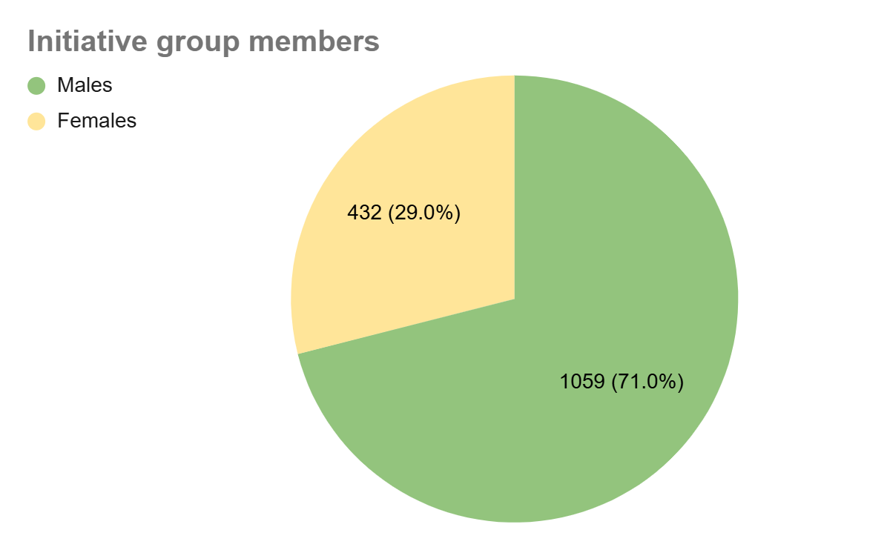

5. Concept note for Initiative group developed and published in four languages (Uzbek, Russian, English, Karakalpak):

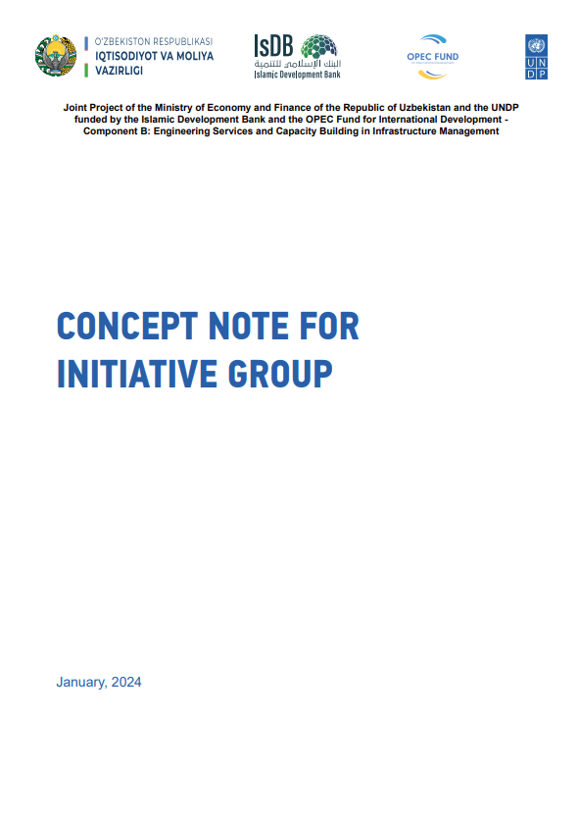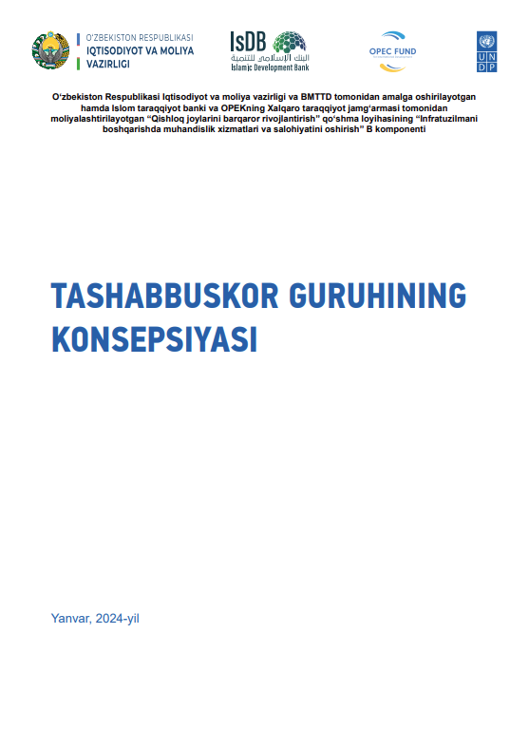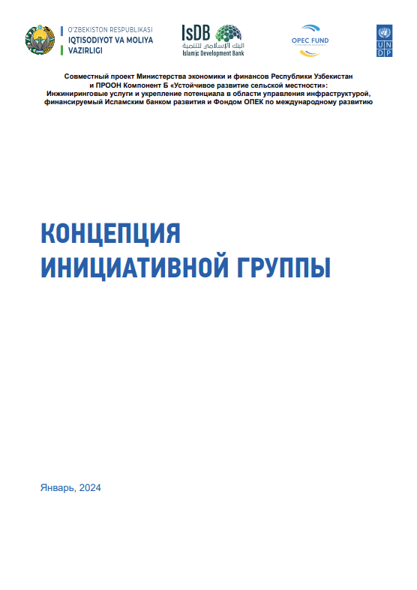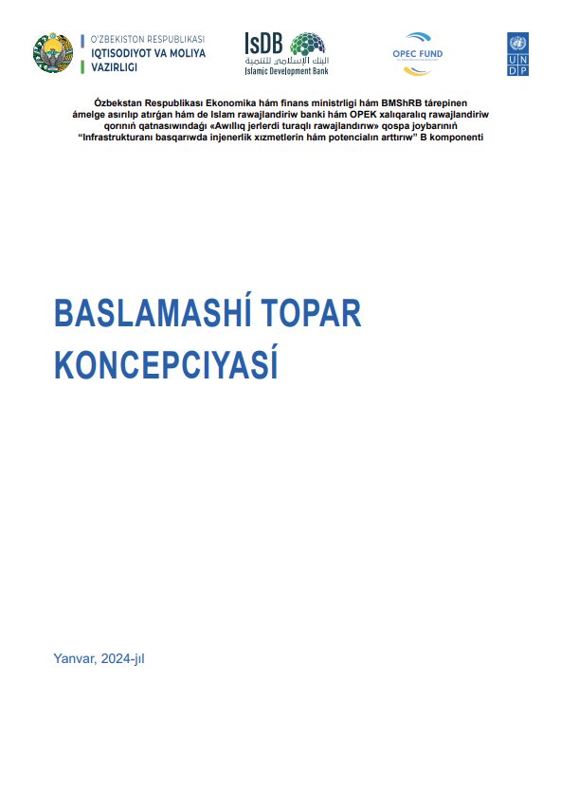

- Training on “PROJECT DESIGN” in 170 communities of 4 pilot regions with more than 1,400 community initiative group members in pilot communities
The handbook “Catalogue of the local and international organizations providing grants for community development” for 170 community initiative groups members.

Photos of TOT on Project Design:
Republic of Karakalpakstan
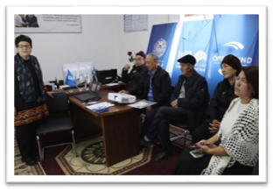Nurli Keleshek MCC, Tahiyatash district | 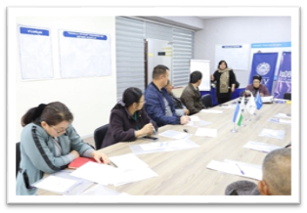Toktau MCC, Nukus district
Khorezm Region
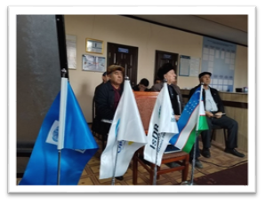Guliston MCC, Khonqa district | 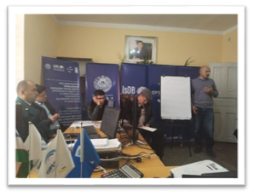Qaramazi MCC, Khonqa district
Navoi Region
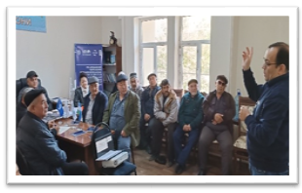Ayronchi MCC, Karmana district | 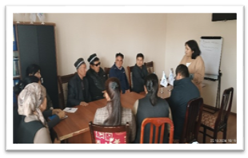Azamat MCC, Karmana district
Bukhara Region
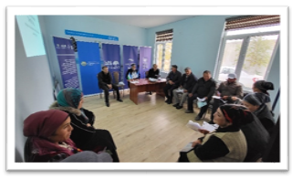Pakhtaobod MCC, Shofirkon district | 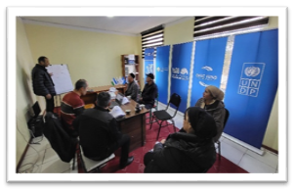  Amirobod-guliston MCC, Bukhara district

Figure 2.
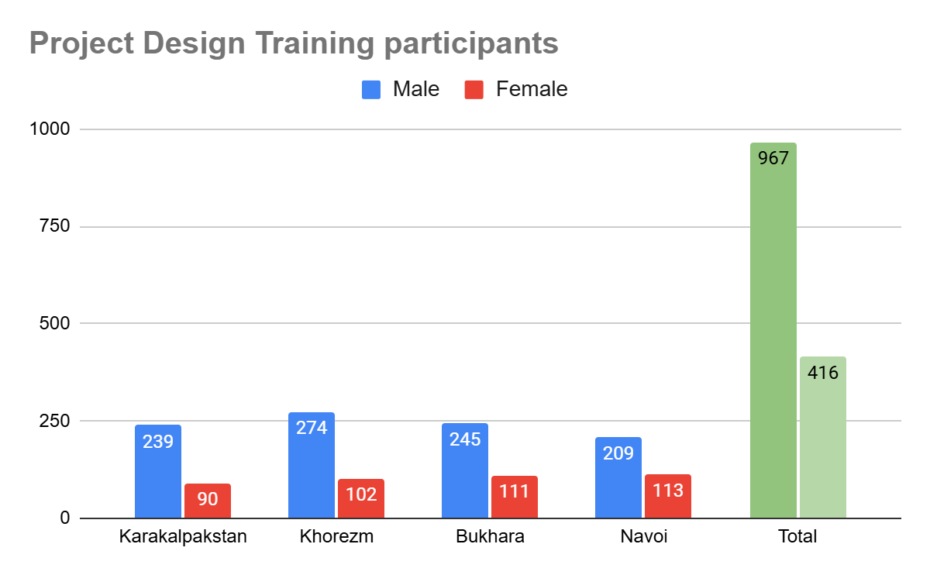
Outputs:
1. 38 representatives of IGs, Ministry of Economy and Finance, PIU and UNDP trained during the Summer School on CDPs, community development, gender, SDGs and sustainability of subprojects
2. The Initiative Groups reviewed - 1491 people including 1059 males and 432 females.
3. 1,383 IG members trained on Project Design including 416 females, and 967 males:
- Karakalpakstan – 324 community members (239 males & 90 females)
- Khorezm – 376 community members (274 males & 102 females)
- Bukhara – 356 community members (245 males & 111 females)
- Navoi – 322 people ( 209 males & 113 females)
4. The handbook “Catalogue of the local and international organizations providing grants for community development” developed.

Activity 1.3 Development and implementation of the gender responsive CDPs at the qishloq/community level (up to 170) relying on extensive and inclusive communities’ mobilization in targeted communities /

Progress:
- Technical verification of selected 900 subprojects conducted
- Annual Review of 40 Cluster Gender Responsive CDPs
Outputs:
      - 900 subprojects verified and 985 subprojects approved by IGs
      - 40 Cluster Gender Responsive CDPs reviewed.
Results of the CDP review:
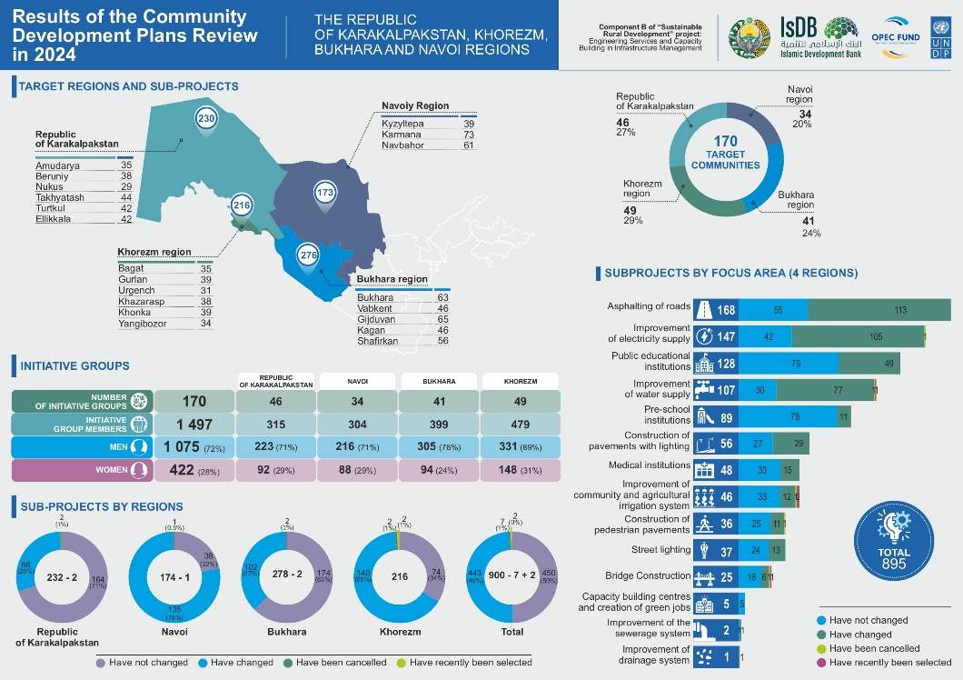
Photos of technical verification visits:
Republic of Karakalpakstan
Tahrikol MCC, Nukus district  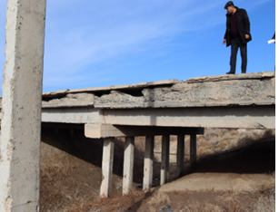 | Doslik MCC, Tahiatash district  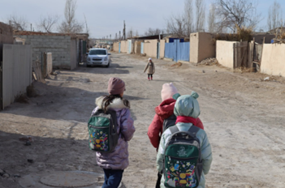
Khorezm Region
Durman MCC, Khonqa district  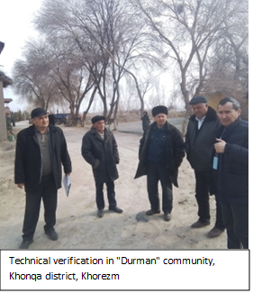 | Qaramazi MCC, Khonqa district  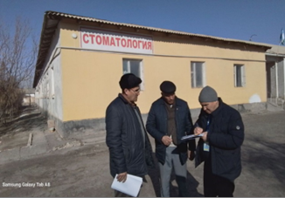
Navoi Region
Rabot MCC, Kiziltepa district  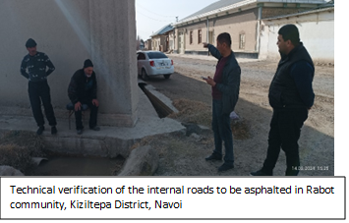 | Navbakhor MCC, Navbakhor district  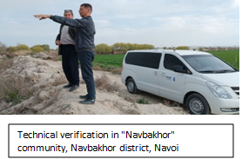
Bukhara Region
Shanba MCC, Vobkent district  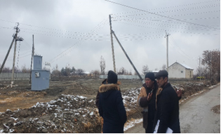 | Talaliyon MCC, Bukhara district  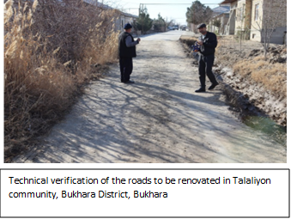

Outputs: N/A

Activity 1.4 Facilitate the institutionalization of the CDPs at the district administration level (inclusion of the CDP priorities and monitoring systems for CDPs into the district development plans of the government), including through engaging the locally selected deputies:
Progress:
- Training on CDP integration for representatives of 20 working groups including district khokimyats, district departments of line ministries and others conducted
- 15 separate thematic indicators – socio-economic environmental maps developed on situational analysis of vulnerability and potential in 4 pilot districts (Takhiyatash, Vabkent, Karmana, and Urgench) across four pilot regions developed and presented to the 4 district khokimyats of four regions.
- Methodology Local Development Llan (LDP) of Vabkent district (Bukhara) to analyze the current situation and explore ways to enhance local capacity for sustainable development by implementing green, energy-efficient, and digital solutions developed.
- Functional analysis conducted in 4 selected pilot communities (Talaliyon in Bukhara, Khidoyat in Khorezm, Zarmetan in Navoi, and Samanbay in Karakalpakstan) to identify strengths and weaknesses in their operations and provide recommendations for improvement.
- Website for monitoring of the CDPs implementation process developed and deployed – the link to the webize: https://srdp.uzrd.uz/

Photos of CDP Integration training:

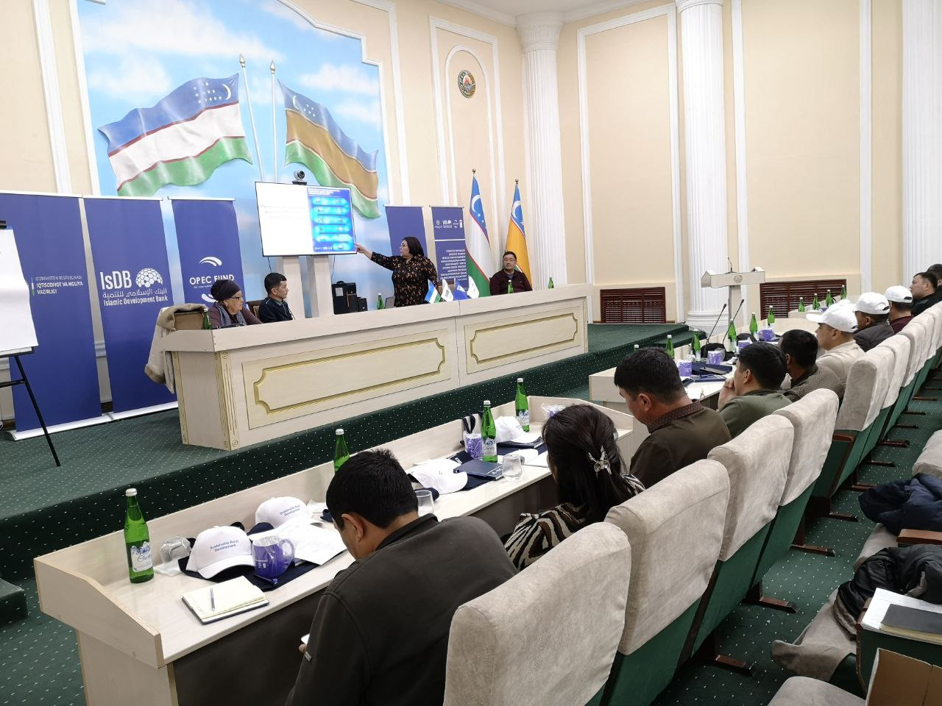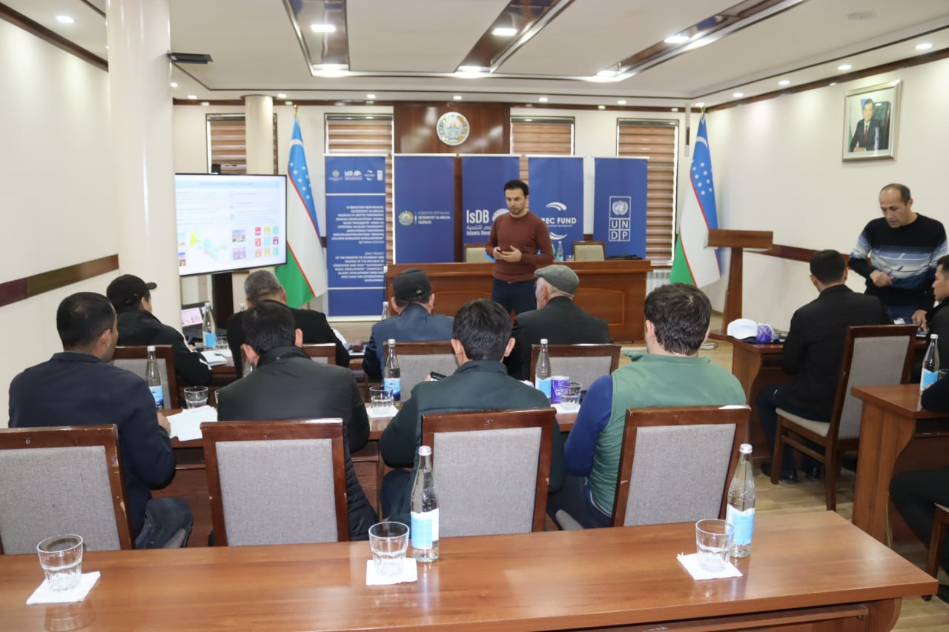

Photos of the CDP monitoring website:
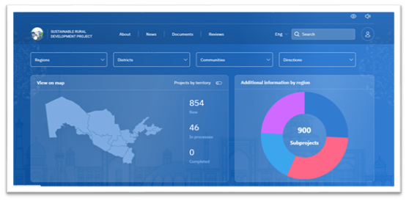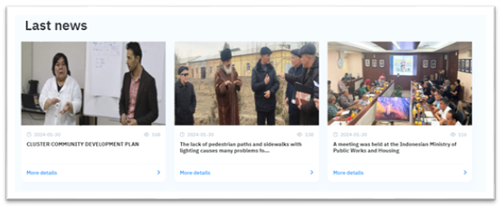
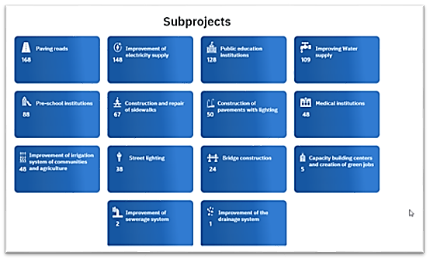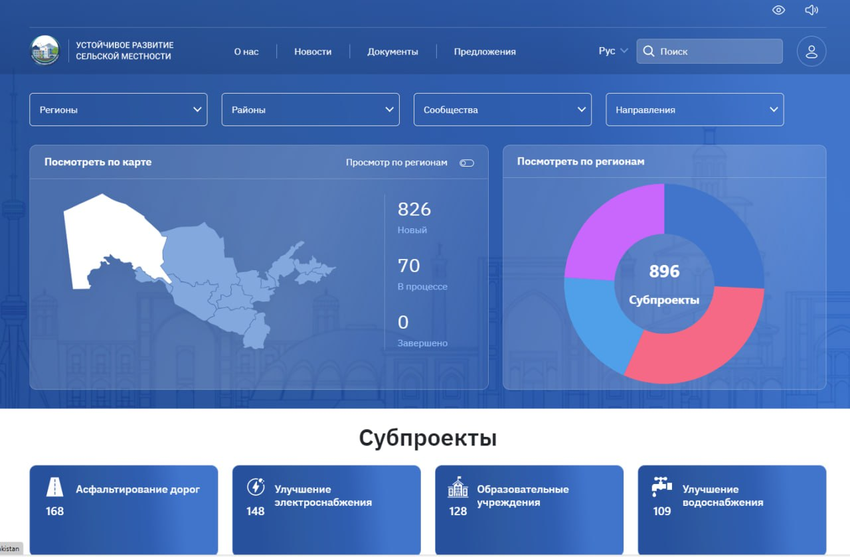

Outputs:
- 250 khokimiyats’ representatives participated in the training on the integration of CDP into the annual planning including 6 females and 244 males.
- 15 visual poverty maps of the existing socio-economic and environmental infrastructure of 4 pilot regions developed. 69 representatives from district khokimiyats participated in the presentations of the poverty maps including 17 females (25%) and 52 males.

Table 3. Subprojects construction status
# | REGION | SUBPROJECTS | NOT  STARTED | TENDER  IN PROCESS | CONSTRUCTION  IN PROCESS
1 | Karakalpakstan | 230 | 195 | 0 | 35
2 | Khorezm region | 216 | 205 | 0 | 11
3 | Bukhara region | 276 | 261 | 0 | 15
4 | Navoi region | 173 | 163 | 0 | 10
TOTAL |  | 895 | 824 | 4 | 70

Activity 1.5 Identification/verification of target communities (around 200 communities) for the 2nd stage of the IsDB Program, from the Samarkand, Kashkadarya and Surkhandarya regions
Activity completed

Activity 1.6 Organization of workshops with community participation (around 1500) and development of around 200 cluster based CDPs.
Activity completed

PROGRESS OF ACTIVITY 2
Capacities of local architecture-design institutions and regional departments of architecture and construction are enhanced for development of improved engineering designs and master plans that are responsive to the sustainability aspects (economic, operational, and environment sustainability), innovative energy and water efficient, low carbon technology, climate resilient and gender responsive, and promoting local resources.
Activity 2.1 Research on adverse impact of the ecological disaster and environment degradation on agriculture and rural population and identification of locally relevant sustainable environmentally friendly solutions
Progress:
- Report on analysis of the adverse impact of ecological disaster and environmental degradation on agriculture and rural population shared with PIU for further dissemination among beneficiary ministries and regional khokimyats;
- Contest on "Adverse Impact of Ecological Disaster in Aral Sea Region" among journalists, photographers, and bloggers. 6 winners were awarded during the project's annual board meeting;
- Methodological guidance “Application of the best foreign practices to overcome the consequences of environmental degradation on the agricultural sector and rural population and recommendations on the implementation of these practices in Uzbekistan” translated into Uzbek language and shared with the PIU for further disseminating among beneficiary ministries and regional khokimiyats.
Outputs:
- 71 contest applications (44 males & 27 females) received, 6 award winners identified
Photos of awarding ceremony:
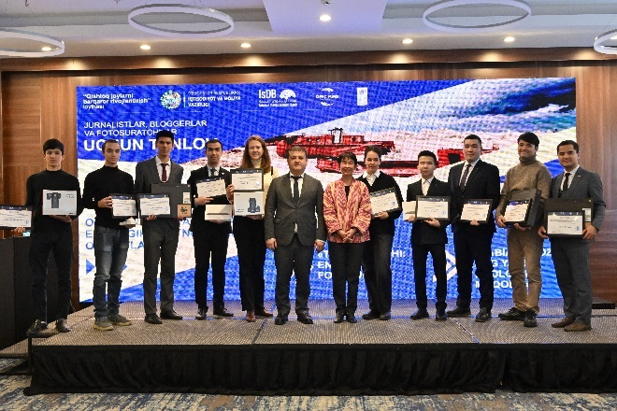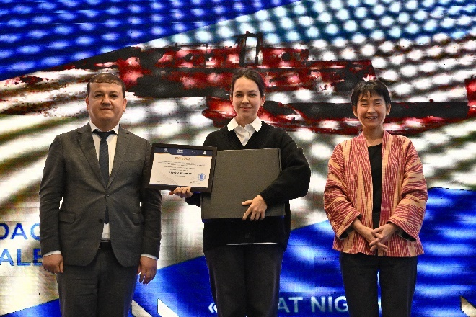

Activity 2.2 Building capacity of local architects/engineers by promoting innovative solutions aimed at energy and water saving, reducing CO2 emission for climate resilient planning, with focus on local agriculture and social infrastructure with particular focus on different needs of concerned groups, including women, youth, people living in poverty and people with disabilities.
Progress:
- Contest on "Smart agriculture" among students organized. 6 contest winners awarded during the 5th annual board meeting;
- a) Training for farmers and agriculture sector specialists on crop diversity was conducted;
b) Training for farmers on the effective use of agro-meteorological stations conducted;
- a) Analytical report on the capacity assessment of the architectural-construction sector and training needs assessment of local specialists in the Aral Sea region shared with National partner, PIU, and relevant ministries;
b) Training on using BIM technology for local specialists and students completed in all 4 pilot regions;
- Study tour to Spain completed on June 16-22, 2024 with the participation of representatives of local khokimiyats and the Ministry of Economy. The visit aimed at learning from Spain's experiences in smart agriculture and sustainable infrastructure, focusing on sustainable urban and rural planning, capacity building for rural specialists, Spain's sustainable development strategies, and innovative agricultural technologies that are energy and water-efficient, ozone-friendly, and have low global warming potential;
Photos of the study tour:
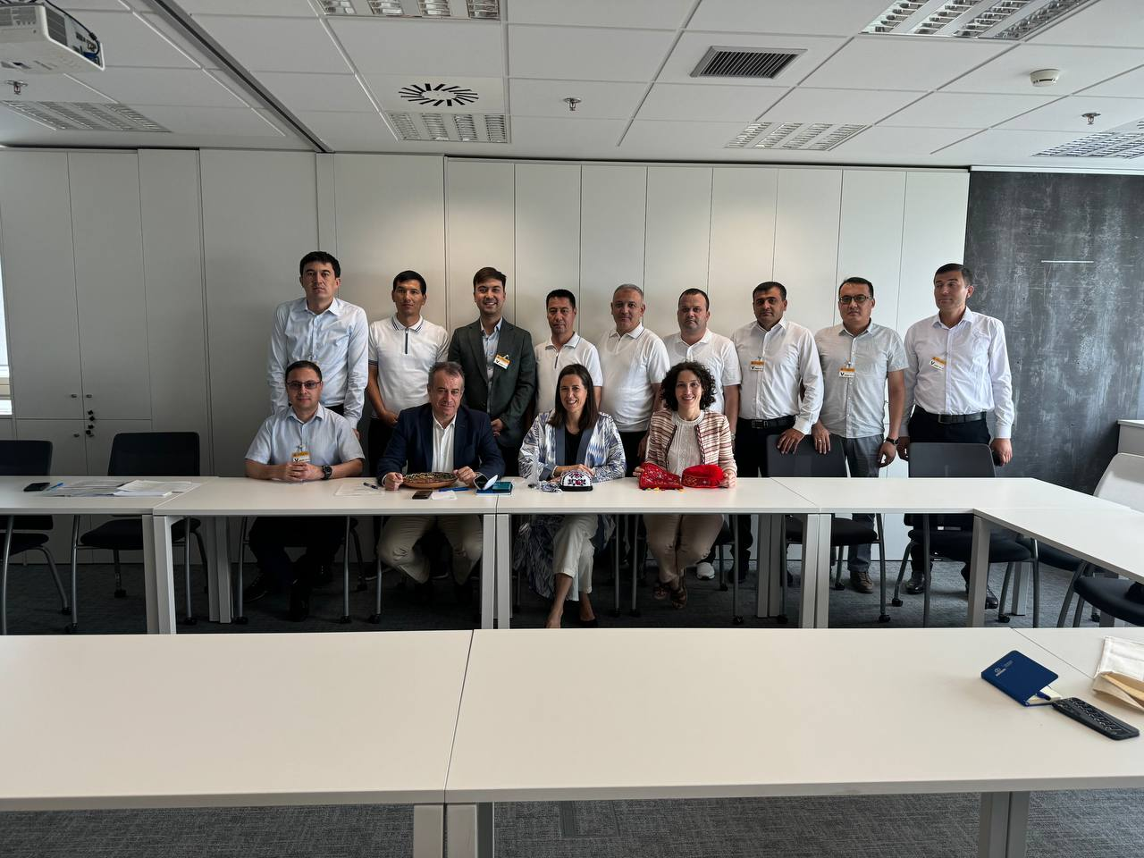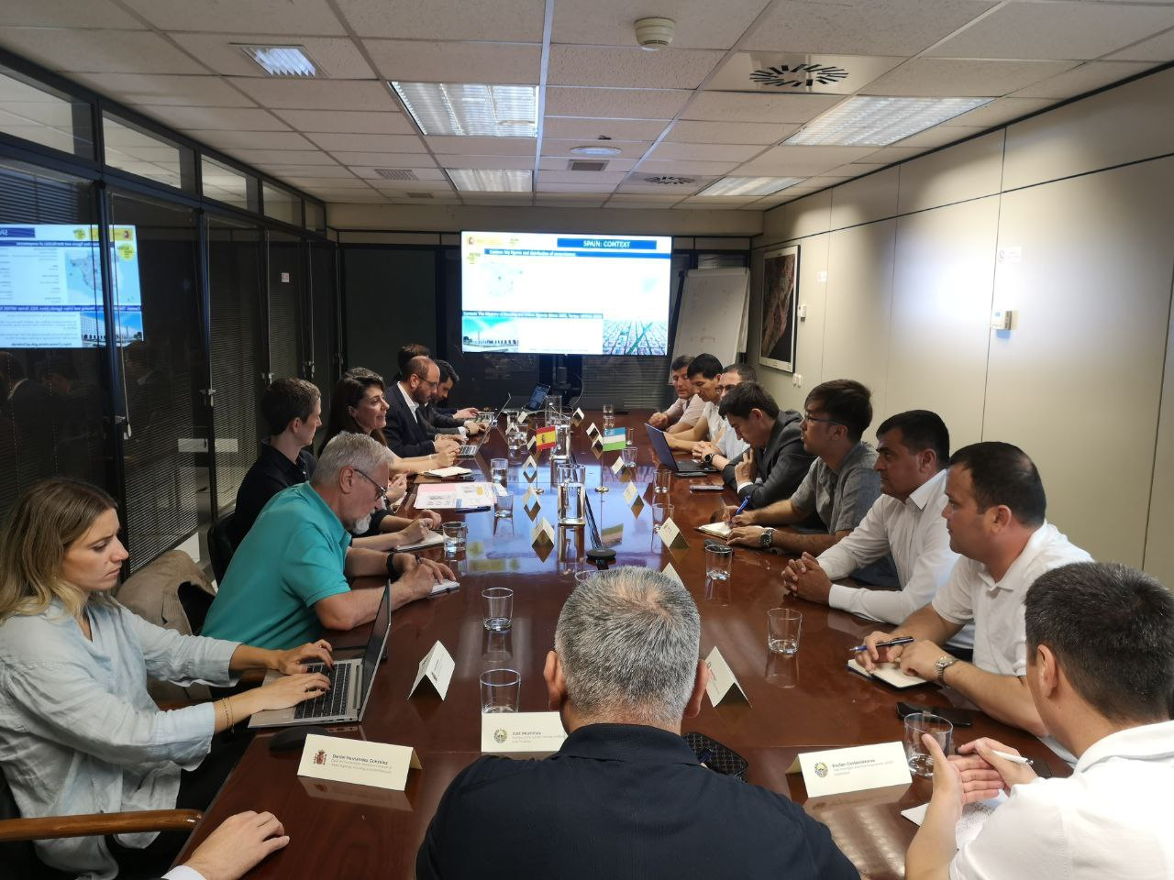
- Procurement process for recruiting consulting company on development of a sustainable of master plan of rural settlement for pilot community finalized;
- Training on climate change and ecological disasters for students conducted.
Outputs:
- 38 contest applications (11 females & 27 males), 6 award winners;
- 78 individuals, including farmers, agriculture, and irrigation specialists, participated in the training on Crop Diversity, with 28 of them being women;
- 69 farmers, agriculture and Uzhydromet specialists trained on the Effective Use of agro-meteorological stations;
- 60 local specialists and students, including 12 women, completed training courses on Building Information Modeling technologies;
- Study tour to Spain with the participation of 7 representatives of local khokimiyats and the Ministry of Economy was successfully conducted;
- 91 students participated in training on climate change and ecological disasters, including 54 girls and 37 girls.

Activity 2.3 Introduction of energy and water efficient, new agriculture & farming technologies, ozone-friendly and low GWP (global-warming potential) based technologies in different sectors/applications in a balanced proportion of pilot projects.

Progress:
- The smart drip irrigation technology in pilot regions developed and Bukhara (Bukhara region) and Karmana (Navoi region) districts selected based on the results of the needs assessment as pilot regions for installation of the drip irrigation system and will be installed in 2025 year.
- Pilot project on implementation of photovoltaic station (solar panel) in social infrastructure in pilot regions - Kogon District (Bukhara), Karmana (Navoi), Ellikkala(Karakalpakstan), Yangibazor (Khorezm) initiated and will be installed in 2025 year.
- Pilot project - Installation of low GWP propane air conditioners has been completed in four regions and training on their use has been conducted. 8 GWP propane air conditioners installed in local healthcare facilities in 4 pilot regions - Kalmikon community in Shofirkon district (Bukhara), Kipchak community in Amudarya district (Karakalpakstan), Madadkor community in Gurlan district (Khorezm), Azamat community in Navbahor district (Navoi).
Table 4. Beneficiaries of agrometeorological stations
# | REGION | DISTRICTS | COMMUNITY | BENEFICIARY-FARMERS
1 | Karakaplakstan | Amudarya | Qipchak | 43
2 | Khorezm region | Khonqa | Gayrat | 97
3 | Bukhara region | Shofirkon | Katta Karvanboshi | 62
4 | Navoi region | Navbakhor | Arabkhona | 29
Total |  |  |  | 231

Table 5. Propane air conditioners’ monitoring at rural medical points
# | REGION | DISTRICTS | COMMUNITY | WORKING STATUS
1 | Karakaplakstan | Amudarya | Qipchak | Functioning properly
2 | Khorezm region | Gurlan | Madadkor | Functioning properly
3 | Bukhara region | Shofirkon | Qalmikon | Functioning properly
4 | Navoi region | Karmana | Azamat | Functioning properly

Outputs:
      - Pilot project on 4 low GWP (propane) air-conditioners installed in 4 rural medical hospitals.
      - 231 farmers use agrometeostations for improvement its profitability.

PROGRESS OF ACTIVITY 3:
Capacities of construction, architecture-design and public service delivery sector are increased on the local governance and community participatory mechanism in the planning and implementation of rural development programs and initiatives by using digital transformation, gender-sensitive approaches, innovative IT solutions, including development of digital infrastructure and information systems to ensure better access to social facilities and services in rural areas, including green redevelopment/regeneration and increasing resilience in post-disaster situations (such as COVID-19 and other pandemics).
Activity 3.1 Digital readiness assessment, including digital gender gap, and development of local digitalization plans:
Activity completed
Outputs:
- Assessment of the existing information technology infrastructure and plans for their development in rural areas shared with PIU for further disseminating among beneficiary ministries and regional khokimiyats
- Two Concept notes on digital solutions presented during the round table:
- "The Power of Light for the Power of Knowledge" - pilot implementation of the flagship Li-Fi technology to expand Internet connectivity in schools
- Pilot implementation of a precision irrigation wireless intelligent automation system based on the Internet of Things in Agriculture (IoT Ag) platform

Activity 3.2 Capacity building to support regional digital transformation (25 people at each supported region, total 100 people)
Progress.
- Training for unemployed young people on “Online trading skills” conducted in regional mono-centers in 4 pilot regions
Photos:
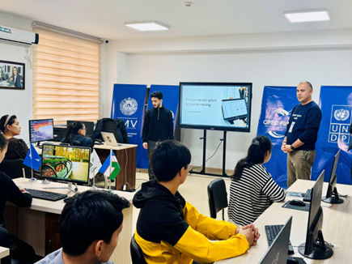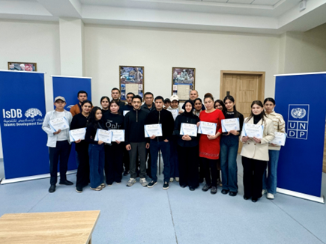
- Training for farmers on Modern Farming Technologies
Outputs:
- 80 young people in four regions including 53 females (64% of females) trained in “Online trading skills”
- 78 people farmers, agriculture, and irrigation specialists including 28 women and 50 men trained on Modern Farming Technologies
Activity 3.3 Increasing digital literacy for rural population in target villages/qishloqs, with focus on students, youth communities, cooperatives, water-users associations, etc.
Progress
- Training on AI among youth including unemployed young people conducted at the regional IT parks of 4 pilot regions. The training covered theoretical and practical aspects of the implementation and use of artificial intelligence in daily life.
Photos of the AI training:
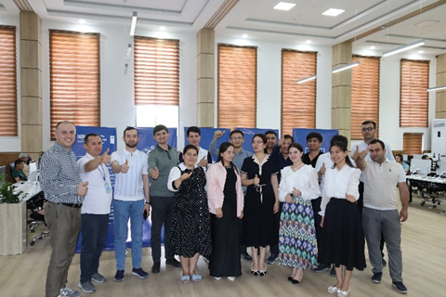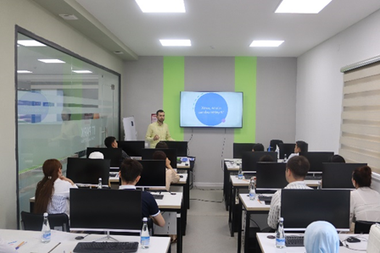

Outputs
- 100 participants including 58 boys and 42 girls trained n AI training

Activity 3.4 Based on the prioritization assessment under activity 3.1., improve access to social infrastructure through using modern technology/equipment and promoting/piloting the smart/green communities’ model.
Progress.
- Pilot project – 8 community resource centers established in 8 communities. 8 information kiosks, printers, and long-range routers were provided to pilot communities and installed in resource centers, enabling the community population to access e-government services locally, without commuting to regional or district centers
- Pilot project on digital solutions for 4 rural schools implemented. IT equipment for 4 rural schools - 68 personal computers, 4 smart boards, and 4 LAN equipment.
- Pilot project on digital solutions for rural hospitals in process. 8 computers, 12 tablets and 4 printers were procured for 4 rural medical points in four regions and will be installed in 2025 year.
- Pilot project on community co-working centers in 4 communities in process. 8 computers, and 4 printers procured for youth co-working centers in 4 regions. 68 PCs, 4 Smartboards and LAN equipment for 4 schools were delivered and will be installed in 2025 year.
Table 6. Community resource centers’ use for online public services (as of November 30, 2024)

Community | Male | Female | Total
Ilgor MCG, Honqa district, Khorezm | 24 | 60 | 84
Kamolot MCG, Khozarasp district, Khorezm | 38 | 52 | 90
Hajuvon MCG, Vobkent district, Bukhara | 13 | 15 | 28
Jovgari MCG, Gijduvon district, Bukhara | 45 | 59 | 104
Dustlik MCG, Karmana district, Navoi | 10 | 16 | 26
Ok machit MCG, Qiziltepa district, Navoi | 2 | 2 | 4
Naymankul MCG, Takhiyatash district, Karakalpakstan | 8 | 18 | 26
Shimom MCG, Beruniy district, Karakalpakstan | 10 | 23 | 33
Grand total | 150 | 245 | 395

Table 7. The use of IT technology at schools (as of November 30, 2024)

Community/school | Boys | Girls | Total
#9, Turtkul dist. Karakalpakstan | 902 | 967 | 1869
#17, Nukus dist, Karakalpakstan | 413 | 403 | 816
#9 Urgench dist, Khorezm region | 508 | 472 | 980
#10, Khozarasp dist, Khorezm region | 562 | 523 | 1085
#6, Shofirkon dist, Bukhara region | 300 | 336 | 636
#28, Vobkent dist, Bukhara region | 459 | 464 | 923
#8, Navbahor dist, Navoi region | 666 | 717 | 1383
#18, Qiziltepa dist, Navoi region | 539 | 513 | 1052
Grand total | 4349 | 4395 | 8744

Photos of IKT and Information kiosk:
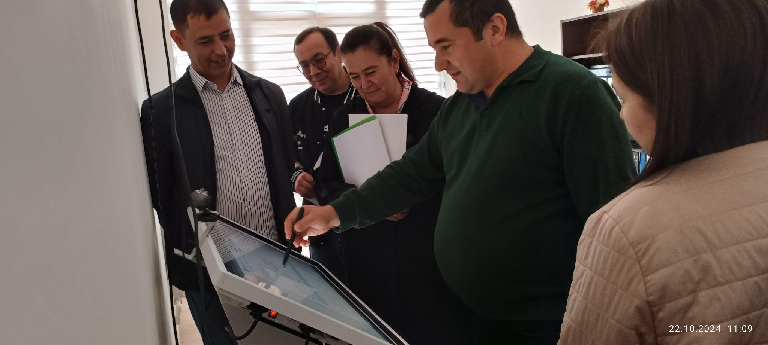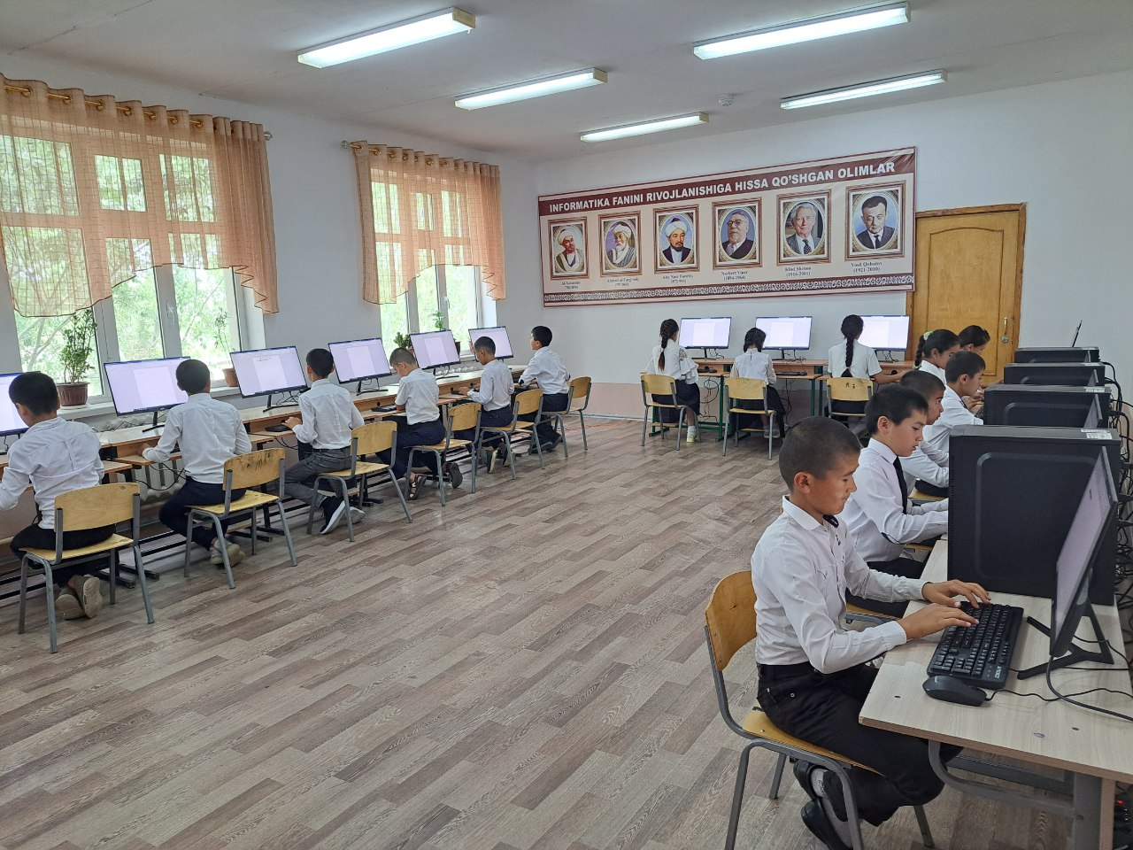

- Rollups, caps, notebooks, mugs, pens, caps, t-shirts, paper folders, information boards, stickers, flags, and other promotional materials developed
Outputs:
- Pilot project on community resource centers implemented and 395 people used the community resource center to receive online public services including 150 males and 245 females in 2024 year.
- Pilot project on digital solutions in rural schools implemented and 8744 students used computers and smart boards including 4349 boys and 4395 girls.

PROGRESS OF ACTIVITY 4:
Local communities are strengthened empowering women, youth, elderly, people with disabilities, involving in decision making processes and national/sub-regional/local government capacities and institutionalization in operation and maintenance of the infrastructure to ensure sustainable functioning.
Activity 4.1 Deployment of methods for effective and sustainable development of infrastructure in rural areas through promoting the local resource-based approaches.
Progress.
- Study tour of rural development, sustainability, capacity building, and CDPs in Latvia and Slovakia was conducted on June 10-20, 2024. The purpose of the tour was to learn about the experiences of EU countries in sustainable rural development, with a particular emphasis on the LEADER program financed by the European Agricultural Fund for Rural Development.
Photos:
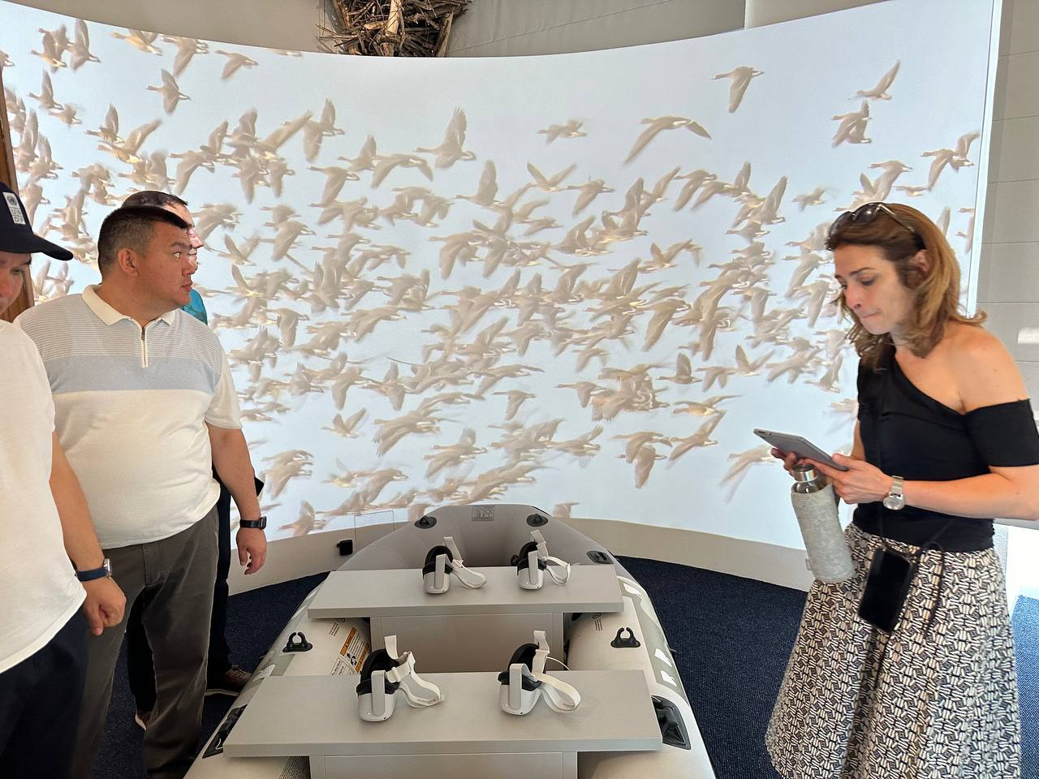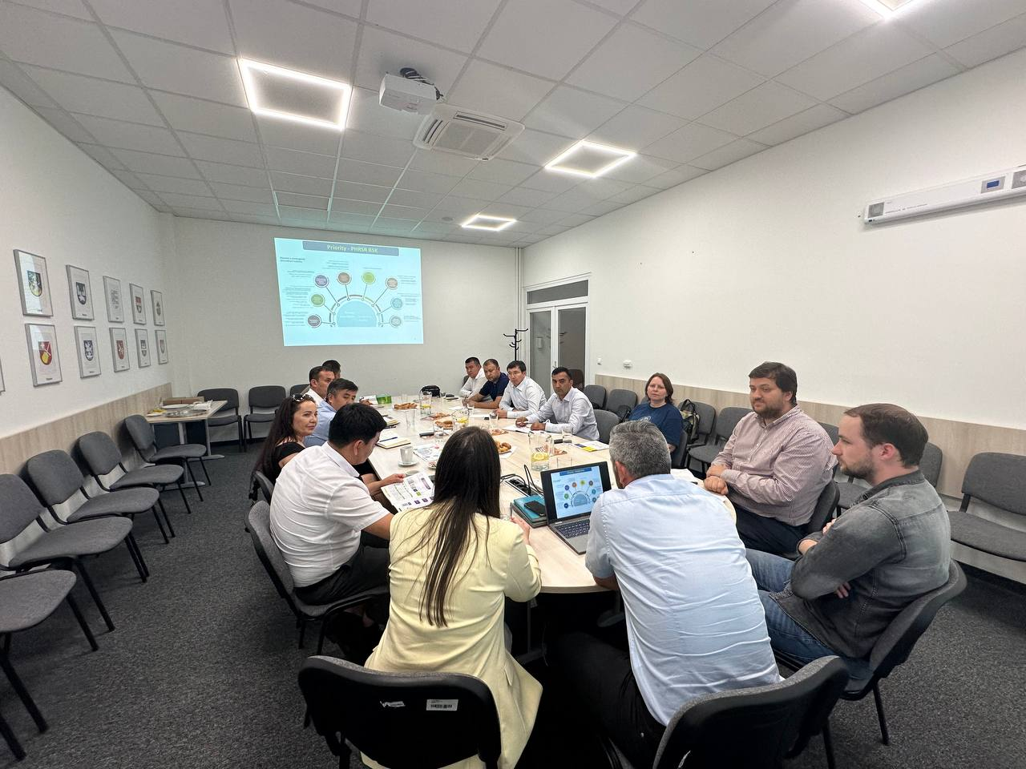

- International training program was held in Turkey, involving project staff and members of the Project Implementation Unit (PIU). The purpose of the training was to enhance capacity and learn about best practices in rural development. Participants focused on developing and implementing strategies for sustainable rural infrastructure development. Additionally, they explored best practices for designing and constructing rural infrastructure in alignment with sustainability goals.
Photos:
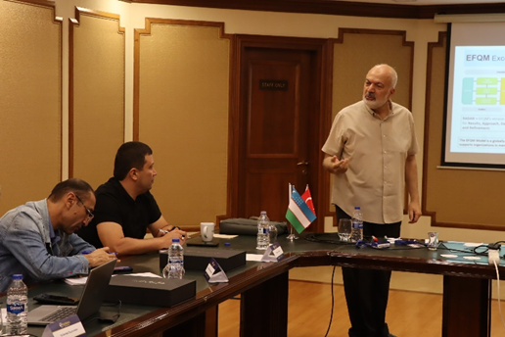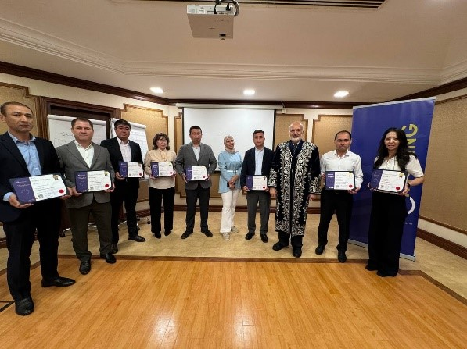

- Monitoring and Evaluation training was conducted in 170 communities of 4 pilot regions. The training focused on sustainable development, use of energy-efficient, low-carbon building materials in construction and monitoring of subprojects implementation process. Initiative groups members participated in the training.
Photos:
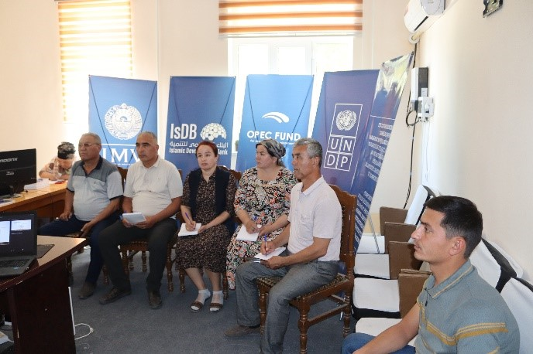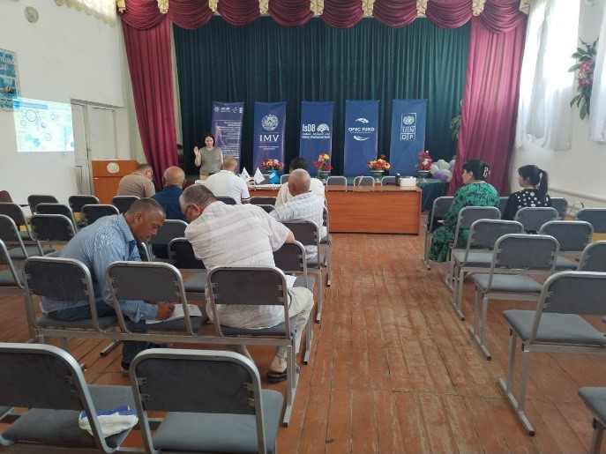

Outputs:
- 9 representatives of local authorities, study tour to Latvia and Slovakia on rural development, sustainability, capacity building and CDPs was successfully conducted on June 10-20, 2024.
- 914 IG members trained in “Monitoring and Evaluation” including 255 females and 659 males in 170 communities.
- Karakalpakstan – 386 community members (295 males & 91 females)
- Khorezm – 331 community members (263 males & 68 females)
- Bukhara – 279 people (212 males & 67 females)
- Navoi – 254 people ( 175 males & 79 females)

Figure 3. Monitoring and Evaluation training participants

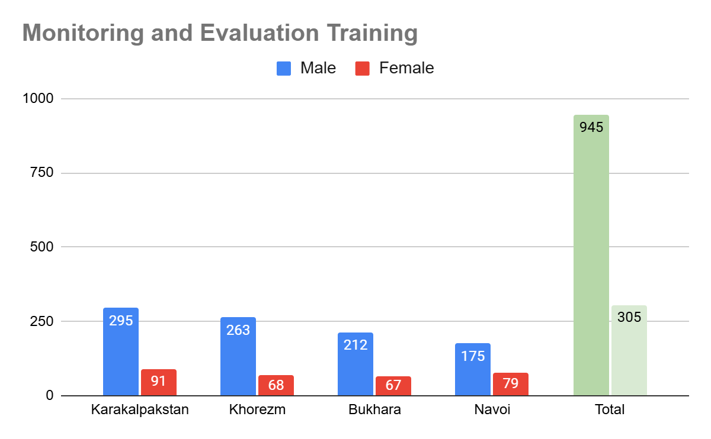

Activity 4.2 Replication of Project best practices
Progress.
      - Concept notes of replication best practices in process.
Activity 4.3 Development of a communication strategy in line with UNDP Principles of Gender-Sensitive Communications to make use of all possible advocacy and outreach tools and approaches to deliver messages to target audience, beneficiaries and wider public at community, district, sub-national, national, and international levels.
Progress.
1. During the reporting period the following advocacy activities were completed (Annex 3 & 4):
- Video reports – 9;
- Press releases – 26;
- Social media posts – 466 (Telegram, Facebook, Linkedin, Twitter, Youtube);
- Infographics, leaflets and posters – 9; (CDP review-2024, results of the trainings, 2 phases of the project, complaint handling mechanism, ecology, and effective use of water and electicity, Leaflet on Monitoring and Evaluation, website instructions)
2. Development of video about target regions (school, kindergarten, hospitals, water/brigde/ electricity facility) demonstrating project impacts initiated - the “before construction” stage of the subprojects filmed;
3. Training for PR specialists of the target regions' hokimiyats conducted in two locations, Bukhara and Khorezm, with the participation of specialists from Bukhara, Navoi, Khorezm, and Karakalpakstan regions.
Outputs:
- 47 PR specialists from 4 regional and 20 pilot districts trained on video and photo filming and posting including 34 males and 13 females.
Photos of PR training:
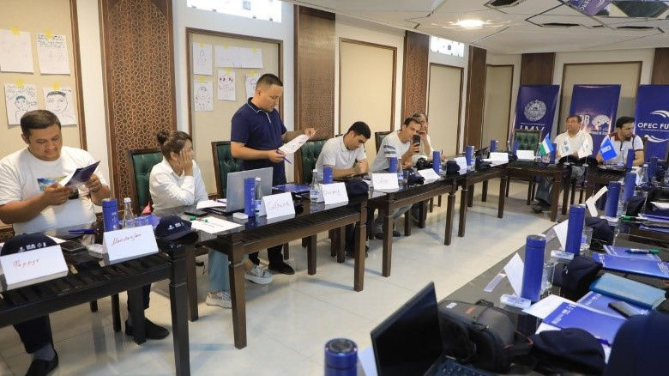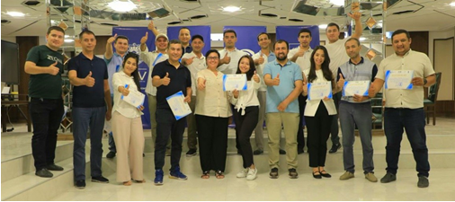

PROGRESS OF ACTIVITY 5:
Project Management.
Progress:
- Annual Plan for Activities and budget for 2025 developed and will be approved by 5th Project Board Meeting.
- The budget revision for 2025 is finalized and reflects budget updates and a slight increase in the annual work plan for 2025
- Annual monitoring and evaluation conducted, and the results will be presented to Project Board Meeting
- 4th Project Board Meeting conducted on March 4, 2024
- 5th Project Board Meeting will be conducted on December 10, 2024
PROJECT RISKS
- Rapid changes in the Central Government structure and on-going restructuring key national partners
- Changing of the CDP priorities due to the other donor interventions, national and regional investment program, and private donations
LESSONS LEARNED AND CHALLENGES
- One of the challenges encountered in engaging members of the Initiative Groups in volunteer project activities is a lack of motivation among certain individuals. Some of the IG members discontinued their involvement in project activities.
- CDPs development process challenges linked to diverse formats and styles across the regions and the necessity to develop universal format for CDPs development across the regions
- To ensure effective use of Information kiosks, Agrometeorological stations, and other project-provided equipment, specialists require sufficient training

Annexes:
Annex 1. Project target reporting table of 2024 and up to date figures
Annex 2. List of assessments, report and learning materials
Annex 3. List of promo materials
Annex 4. List of publications
Annex 5. List of transfer documents
Annex 6. Donor Interim report
Annex 7. Request for 4th installment

